Sprint 2 Speed Design Document

November 12, 2019

Bryan Le
Kiki Kanik
Veronica Marquez
Table of Contents
1. Executive Summary 3
1.1 Project Overview 3
1.2 Purpose and Scope of this Specification 3
2. Product/Service Description 3
2.1 Product Context 3
2.2 User Characteristics 3
2.3 Assumptions 3-4
2.4 Constraints 3
2.5 Dependencies 4
3. Requirements 4
3.1 Functional Requirements 5
3.2 Security 5
3.2.1 Protection 5
3.2.2 Authorization and Authentication 6
3.3 Portability 6
4. Requirements Confirmation/Stakeholder sign-off 6
5. System Design 6
5.1 Algorithm 6
5.2 System Flow 7
5.3 Software 7
5.4 Hardware 7
5.5 Test Plan 7-8
5.6 Task List/Gantt Chart 9
5.7 Staffing Plan 9

Executive Summary

Project Overview
A robot must successfully travel around the figure 8 layout in HH208, while speaking and displaying colors at the end. This project will be presented to the class of CS-104-03, Professor Eckert, and potentially any other staff or student in the Computer Science/Software Engineering department.

Purpose and Scope of this Specification
The purpose of this project is to see if the robot can speed around a set figure without going out of the given parameters. The purpose of this specification is to test the ability of the robot to follow directions when given by the developer. The intended audiences are all students and staff in the Computer Science/ Software Engineering department who have a well-rounded knowledge of the project and the concepts surrounding the project.

Product/Service Description
Sphero edu is a company that is based around teaching and educating students about math, science, arts, social studies, and coding. Specifically, we are using a robot that was created by Sphero called “BOLT” to be used to help teach students (and those interested) how to code.
Sphero’s BOLT has an electric senor that can be used to detect light. It also has a compass in it that can be used to direct the robot north. The robot has Bluetooth and can be connected to one device at a time. There is an app that can be download on types of devices to command the robot using javascript/block code.
Factors that could potentially affect the product’s performance is its software, the personal ability of the sphere robot and the knowledge and precision of the user. Since the robot is spherical, it is not precise in its movements. Depending on the user’s precision and placement, the route of the robot can be perfect or very off. The software of the robot has not been made to accommodate this issue, but otherwise, it is very user-friendly.

Product Context
This product relates to other products by the self-operating function. Other products such as a Roomba are programmed to go around the whole house and vacuum. It is self-contained. Yes, it does interface with a variety of related systems. The robot relies on the Sphero app and coding to be able to function in the way the user desires it to function.

User Characteristics
USER | EXPERIENCE LEVEL | TECHNICAL EXPERIENCE | REASON FOR USING BOLT
Student | Beginner | None | Competition / to learn how to code / class project
Student | Intermediate | Some | Competition / to hone coding skills /class project
Student | Advanced | A lot | Competition / for fun / class project
Faculty | Beginner | None | Because Prof Eckert asked them
Faculty | Intermediate | Some | Because Prof Eckert asked them
Faculty | Advanced | A lot | Because Prof Eckert asked them
Random | Beginner | None | For fun / to help teach
Random | Intermediate | Some | For fun / to help teach
Random | Advanced | A lot | For fun / to help teach

Assumptions
The robot will be connected to Bluetooth to operate/run
The robot runs on block/JavaScript code
The robot will be able to complete the course provided for by Prof Eckert

Constraints
- There may be an updated and better operating system.
- Security may be weak b/c others could have access to the code that’s programmed in the robot
- Robot’s framework is a sphere so you can’t accurately point it in the direction you want it to go to.

Dependencies
The robot requires coding in order for it to operate.
It requires testing so it can operate correctly and efficiently.

Requirements
- The robot must be programmed to meet task requirements.
- The robot must successfully travel around the room without interruption.
- The robot must run the figure 8 course
- The robot must run and complete the obstacle course

Functional Requirements
Req# | Requirement | Comments | Priority | Date Rvwd | SME Reviewed / Approved
ENDUR_01 | The robot should start and finish in the same place as indicated by the course | Have to find a way to code the robot so it can go through the course | 1 | 11/01/19 | 11/07/19
ENDUR_02 | The robot should continue around the figure 8 without straying from the path | we have to find a way to aim the robot perfectly so the robot doesn’t stray from the path | 2 | 11/01/19 | 11/07/19
ENDUR_03 | The robot should go around the figure 8 without straying or stopping during the run | Create a loop that will allow the robot to run around the figure 8 for five times | 3 | 11/01/19 | 11/03/19
ENDUR_04 | The robot will end speaking “I am the winner” | In the program have to code so the robot will speak promptly | 4 | 11/01/19 | 11/01/19
ENDUR_05 | The robot will end and flash multicolored lights for 5 seconds | In the program have to code so the robot will display colors for 5 seconds | 5 | 11/01/19 | 11/01/19

Security

Protection
“We responsibly source critical components from trusted vendors & suppliers. We also audit our factories for ethical worker treatment. The hardware that we create is loaded with ﬁrmware that is developed to ensure proper functionality and security of the system. Each robot we create is built with a batch serial number to identify any issues that may arise, and to facilitate logistics.”

Authorization and Authentication
Sphero edu promises authenticity with all its products. An internal security review and audits are done routinely on their products. There is an automated security monitoring that Sphero provides on all it’s products to check on the code and o fix any issues that may arise. Verified data Encryption. Sphero follows the guidelines drawn up by the Children's Online Privacy Protection Act (COPPA) to ensure the safety and privacy of child users.
To find out more about the product’s security, click on the hyperlink below: https://s3.amazonaws.com/static.gosphero.com/downloads/infographic/Sphero-Safety-Infographic.pdf

Portability
The Sphero code is portable because it can be used from multiple devices to work, such as desktop, laptop, iPad, phones.

Requirements Confirmation/Stakeholder sign-off
Meeting Date | Attendees (name and role) | Comments
11/03/19 | Bryan Le (Assistant Manager)  Kiki Kanik (Management)  Veronica Marquez (Project Manager) | We each went over our tasks and approved the code
11/07/19 | Bryan Le (Assistant Manager)  Kiki Kanik (Management)  Veronica Marquez (Project Manager) | We went over what each member has done thus far since meeting on 11/03/19. Discussed any problems the team was facing and tried to resolve them if possible.
11/11/19 | Bryan Le (Assistant Manager)  Kiki Kanik (Management)  Veronica Marquez (Project Manager) | We went over the last finishing touches of all areas of the project which include code, document, flow chart, gnatt chart

System Design

Algorithm
- Place robot on the “X”
- Heading 0 degrees
- Delay the robot for 0.5s
- Set the speed at 65
- Spin for 358 degrees for 4.2 seconds
- Spin for -358 degrees for 4.2 seconds
- Repeat steps 5-6 for 5 loops
- The robot will stop and say “I am the winner” while flashing multicolored lights

System Flow
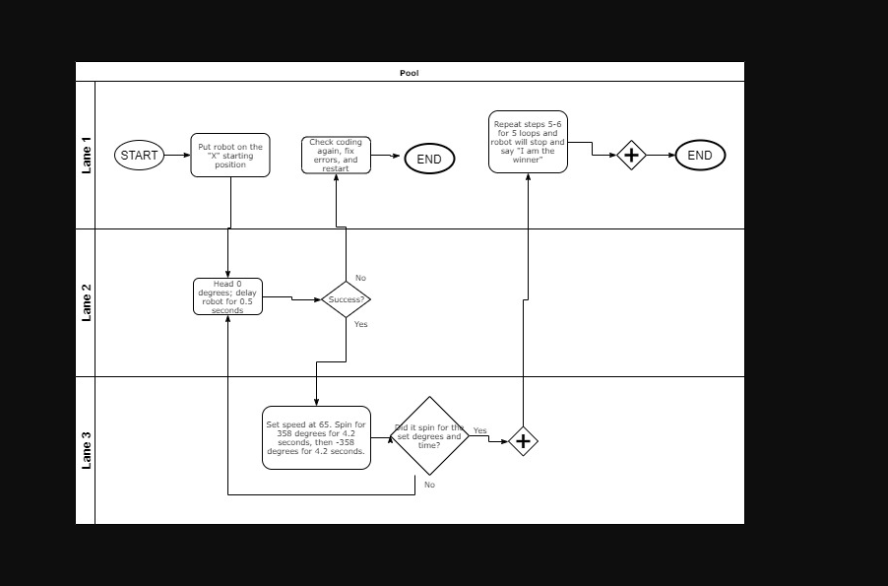

Software
The software that will be used to develop this project is block coding, including javascript behind the block coding itself.

Hardware
The hardware that is going to be used is to ensure the project will run is a

Test Plan
Reason for Test Case | Test Date | Expected Output | Observed Output | Staff Name | Pass/Fail
Aim the robot | 11/01/19 | The blue light will be aimed towards the direction needed | The blue light was aimed properly towards wanted direction | Veronica Marquez | Pass
Run robot | 11/01/19 | The robot will go from start position heading around the figure 8 | The robot went in the opposite direction, away from the starting point | Veronica Marquez | Fail
Re-aim robot | 11/01/19 | The blue light will be aimed again towards the direction wanted | The blue light was aimed as wanted | Veronica Marquez | Pass
Re-run robot | 11/01/19 | The robot will go from start position heading towards the figure 8 | The robot went towards the figure 8 course, blue light was aimed correctly | Veronica Marquez | Pass
Robot stays on the path | 11/01/19 | To ensure robot goes from starting point to the next point, staying on the path | The robot went out of the path | Veronica Marquez | Fail
Re-run robot to stay on the path | 11/01/19 | To ensure robot goes from starting point to complete the 1st circle | The robot went out of the path once again | Veronica Marquez | Fail
Re-aim robot | 11/01/19 | The blue light will be aimed once again to ensure it is properly straight so the robot doesn’t go off the path | The blue light was aimed as straight as I thought it was | Veronica Marquez | Pass
Re-run robot to see if it stays on the path | 11/03/19 | To ensure robot will stay on the path from starting point to complete the whole figure 8 | Robot stayed on the path | Veronica Marquez | Pass
Ran the robot from start to finish | 11/03/19 | To ensure the robot can endure going around the figure 8 without going out of the parameters | Robot 3rd loop around started to slowly go off the blue layout of figure 8. | Veronica Marquez | Fail
Re-run the robot from start to finish | 11/03/19 | To ensure robot will stay on the path the whole time | Robot stayed on the path for the whole run except for the endpoint it missed the “X” | Veronica Marquez | Fail
Re-aimed the robot | 11/03/19 | To ensure the blue light is as straight towards the direction wanted | The blue light was aimed as straight as I thought was necessary | Veronica Marquez | Pass
Re-run the robot from the start to finish | 111/07/19 | To ensure the robot can endure going around the figure 8 without going out of the parameters given | The robot went around the figure 8 successfully and stayed in the blue figure without going out | Veronica Marquez | Pass

Task List/Gantt Chart
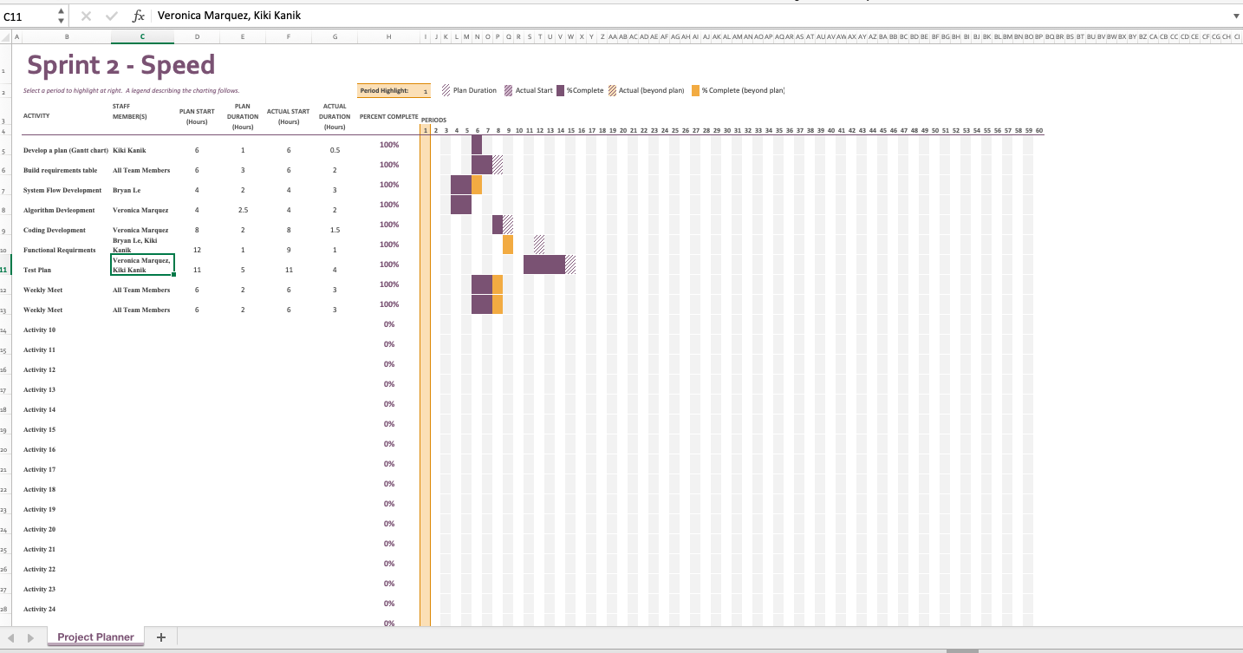

Staffing Plan
Name | Role | Responsibility | Reports To
Veronica Marquez | Project Manager, Coder, Tester | Responsible for all project deliverables, update the project plan.  Write the code that will allow the robot to achieve the requirements.  Test the written code to ensure no errors are presented with the robot and the code itself. | Prof. Eckert, Team
Kiki Kanik | Management | Paperwork, Co-Tester | Prof. Eckert, Team
Bryan Le | Assistant Manager | Complete Documents | Prof. Eckert Team

